Bug Report
ID | 100123
Title | Arithmetic error thrown for fee_pct in FeeCalculator function
Sprint | Sprint 1 (2006/08/17 - 2006/08/28)
Test Type | Functional testing
Business Impact (H/M/L) | High: Processing logic error.
Environment (Dev/Prod) | Dev
Issue:
- FeeCalucator .applyFee attempts to handle NULL values as 0 when performing calculations.

Reproduction Steps:
- Monitor BatchDistributionJob logs for the below reproduction steps
- Use attached csv artifact for testing - configured as follows:
1st has a 0 value for fee_pct (expected to be processed successfully)
2nd has a NULL value for fee_pct (expected to be fail and throw error in logs)
- Start distribution run using the above csv file.
Expected Result:
- 1 record failed, 1 record succeeded.
- Failed record should throw java.lang.ArithmeticException: / by zero

Artifacts:
Test artifact:

Error log:
- 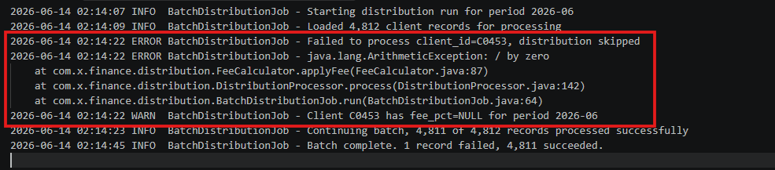

Root Cause Analysis:
- When passing in a NULL value for fee_pct, the FeeCalculator.applyFee attempts to perform the calculation with 0, resulting in the java.lang.ArithmeticException: / by zero error.
- Dev and QA need to investigate the FeeCalculator.applyFee method to correct error handling for NULL values.

